

Kaiser and Kaiser CC
The Cliff, 44 Umbulane Road
Kloof, 3610
T: +27 87 822 1808; birgit@kaiserandkaiser.co.za

PAIA MANUAL FOR AND IN RESPECT OF THE FOLLOWING COMPANIES:

Kaiser and Kaiser CC

(A Private Body)

MANUAL PREPARED IN ACCORDANCE WITH SECTION 51 OF THE PROMOTION OF ACCESS TO INFORMATION ACT,
NO. 2 OF 2000, AND TO ADDRESS THE REQUIREMENTS OF THE PROTECTION OF PERSONAL INFORMATION ACT,
NO. 4 OF 2013, IN RESPECT OF KAISER AND KAISER CC ("Manual")

Version | Policy Owner | Date
1 | Kaiser and Kaiser CC | 2nd June 2025

Kaiser and Kaiser CC Registered with the PPRA. Holder of a Business Property Practitioner FFC. Operating a Trust Account.
Reg No: 2001/068170/23 VAT No: 4860 196 411
Managing Member: BE Kaiser Holder of a Principal FFC, Master Practitioner Real Estate

Table of Contents
1 PREAMBLE 3
2 INTRODUCTION 3
3 OBJECTIVES OF THIS MANUAL 4
4 DEFINITIONS 4
5 SCOPE OF THE MANUAL 6
6 HOW TO USE PAIA TO ACCESS INFORMATION 6
7 ABOUT THE KAISER AND KAISER CC 7
8 KAISER AND KAISER CONTACT DETAILS 7
9 AUTOMATICALLY AVAILABLE INFORMATION 8
10 INFORMATION HELD IN TERMS OF PAIA 8
11 INFORMATION HELD IN TERMS OF OTHER LEGISLATION 9
12 REQUEST PROCEDURE 9
13 PRESCRIBED FEES 10
14 DECISION ON REQUEST 10
15 TIMELINES FOR CONSIDERATION OF A REQUEST 11
16 GROUNDS FOR REFUSAL OF ACCESS TO RECORDS 11
17 REMEDIES AVAILABLE TO A REQUESTER ON REFUSAL OF ACCESS 13
18 RECORDS THAT CANNOT BE FOUND 14
19 PROCESSING OF PERSONAL INFORMATION IN TERMS OF POPIA 14
20 AVAILABILITY OF THIS MANUAL 19
21 PRESCRIBED FORMS AND FEE STRUCTURE 19

LIST OF ANNEXURES
Annexure A Categories and types of records held by Kaiser and Kaiser CC
Annexure B Information kept by Kaiser and Kaiser CC in accordance with other legislation
Annexure C Request for access to record
Annexure D Fees in Respect of Private Bodies
Annexure E Outcome of request and fees payable

PREAMBLE
1.1 The Promotion of Access to Information Act, No. 2 of 2000 ("PAIA"), came into operation on 9 March 2001.
1.2 PAIA seeks, among other things, to give effect to the constitutional right of access to any information held by
the State, or by any other person, where such information is required for the exercise or protection of any right, and gives natural and juristic persons the right of access to records held by either a Private Body or Public Body, subject to certain limitations, in order to enable them to exercise or protect their rights.
1.3 Where a request is made in terms of PAIA to a Private Body, that Private Body must disclose the information
if the Requester is able to show that the record is required for the exercise or protection of any rights and provided that no grounds of refusal contained in PAIA are applicable. PAIA sets out the requisite procedural issues attached to information requests.
1.4 Section 51 of PAIA obliges a Private Body to compile a manual, to enable a person to obtain access to
information held by such Private Body and stipulates the minimum requirements that the manual has to comply with.
1.5 The Protection of Personal Information Act, No. 4 of 2013 ("POPIA") promotes the protection of Personal Information processed by a Private Body or Public Body, including certain conditions so as to establish minimum requirements for the Processing of Personal Information.
1.6 POPIA amends certain provisions of PAIA, balancing the need for access to information against the need to
ensure the protection of Personal Information, by providing for the establishment of an Information Regulator to exercise certain powers and perform certain duties and functions in terms of POPIA and PAIA, the issuing of codes of conduct, and the rights of persons regarding unsolicited electronic communications and automated decision making, to regulate the flow of Personal Information and to provide for matters concerned therewith.

INTRODUCTION
2.1 This Manual has been prepared in accordance with section 51 of PAIA, as amended.
2.2 This Manual serves as Kaiser and Kaiser CC information manual and provides reference to the records held
by Kaiser and Kaiser CC, as well as the Personal Information Processed by Kaiser and Kaiser CC from time to time.
2.3 This Manual replaces all previous manuals compiled and published prior hereto in respect of Kaiser and Kaiser CC
2.4 This Manual will be updated from time to time, and as soon as this Manual is updated, the latest version of the Manual will be published and distributed in accordance with PAIA (see section 51(2) of PAIA).
2.5 A Requester is invited to contact the Information Officer or Deputy Information Officer should the Requester
require any assistance in respect of the use or content of this Manual.
2.6 The definitions provided in this Manual are solely for the purpose of this Manual and are not to be taken as
applicable to PAIA.

OBJECTIVES OF THIS MANUAL
3.1 The objectives of this Manual are:
3.1.1 ensure that Kaiser and Kaiser CC complies with PAIA by giving the effect to the right to information;
3.1.2 set out the procedural requirements attached to requests for records in terms of PAIA, the requirements
which requests must meet, as well as the grounds for refusing requests;
3.1.3 provide a non-exhaustive list of Personal Information, records, and other details held or collected Kaiser and Kaiser CC; and
3.1.4 record the conditions and terms for Processing Personal Information.

DEFINITIONS
4.1 The following words or expressions will bear the following meanings in this Manual:
4.1.1 "Consent / Consents" means a voluntary, specific and informed expression of will in terms of which a Data Subject agrees to the processing of Personal Information relating to him or her or it;
4.1.2 "Data Subject" means the natural or juristic person to whom Personal Information relates;
4.1.3 "Deputy Information Officer" means any or all of Kaiser and Kaiser CC designated deputy information
officers;
4.1.4 "Information Officer" means Kaiser and Kaiser CC designated information officer;
4.1.5 "Information Regulator" means the information regulator established in terms of section 39 of POPIA;
4.1.6 "Manual" means this manual prepared in accordance with section 51 of PAIA, and to address the
requirements of POPIA, together with all annexures thereto;
4.1.7 "PAIA" means the Promotion of Access to Information Act, No. 2 of 2000, as amended from time to time,
together with any regulations published thereunder;
4.1.8 "Personal Information" means information relating to an identifiable, living, natural person, and where it
is applicable, an identifiable, existing juristic person including, but not limited to:
4.1.8.1 information relating to the race, gender, sex, pregnancy, marital status, national, ethnic or social origin,
colour, sexual orientation, age, physical or mental health, well-being, disability, religion, conscience, belief, culture, language and birth of the person;
4.1.8.2 information relating to the education or the medical, financial, criminal or employment history of the
person;
4.1.8.3 any identifying number, symbol, email address, physical address, telephone number, location
information, online identifier or other particular assignment to the person;
4.1.8.4 the blood type or any other biometric information of the person;
4.1.8.5 the personal opinions, views, or preferences of the person;
4.1.8.6 correspondence sent by the person that is implicitly or explicitly of a private or confidential nature or
further correspondence that would reveal the contents of the original correspondence;
4.1.8.7 the views or opinions of another individual about the person; and
4.1.8.8 the name of the person, if it appears with other personal information relating to the person or if the
disclosure of the name itself would reveal information about the person, which may include Special Personal Information;
4.1.9 " Kaiser and Kaiser CC " means the entities specific on the cover page of this Manual (including such entities'
subsidiaries);
4.1.10 "POPIA" means the Protection of Personal Information Act, No. 4 of 2013, as amended from time to time,
together with any regulations published thereunder;
4.1.11 "Private Body" means:
4.1.11.1 a natural person who carries or has carried on any trade, business or profession, but only in such
capacity;
4.1.11.2 a partnership which carries or has carried on any trade, business or profession;
4.1.11.3 any former or existing juristic person; or
4.1.11.4 a political party, but excludes a Public Body;
4.1.12 "Process / Processed / Processing" means any operation or activity or any set of operations, whether or
not by automatic means, concerning Personal Information, including:
4.1.12.1 the collection, receipt, recording, organisation, collation, storage, updating or modification, retrieval,
alteration, consultation or use;
4.1.12.2 dissemination by means of transmission, distribution or making available in any other form; or 4.1.12.3 merging, linking, as well as blocking, degradation, erasure or destruction of information;
4.1.13 "Public Body" means:
4.1.13.1 any department of state or administration in the national or provincial sphere of government or any
municipality in the local sphere of government; or
4.1.13.2 any other functionary or institution when:
4.1.13.2. exercising a power or performing a duty in terms of the Constitution of the Republic of South Africa, 1996, or in terms of a provincial constitution; or
4.1.13.2.2 exercising a public power or performing a public function in terms of any legislation;
4.1.14 "Requester" means any person or entity or a person acting on behalf of such a person, requesting access
to a record that is under the control of Kaiser and Kaiser CC; and
4.1.15 "Special Personal Information" means personal information as referred to in section 26 of POPIA.

SCOPE OF THE MANUAL
5.1 This Manual has been prepared in respect of and applies to Kaiser and Kaiser CC
6 HOW TO USE PAIA TO ACCESS INFORMATION
(Information provided in terms of section 51(1) of PAIA)
6.1 PAIA grants a Requester access to records of a Private Body, if the information is required for the exercise or
protection of a legitimate right.
6.2 The exercise of an individual's rights is subject to justifiable limitations, including the reasonable protection of
privacy, commercial confidentiality, and effective, efficient and good governance.
6.3 If a Public Body lodges a request in terms of PAIA, the Public Body must be acting in the public interest.
6.4 Requests in terms of PAIA shall be made in accordance with the prescribed procedures, and at the prescribed
fees.
6.5 The Information Officer is responsible for receiving and coordinating all requests for access to records in terms
of PAIA, to ensure Kaiser and Kaiser CC proper compliance with PAIA and POPIA.
6.6 The Information Officer will facilitate the liaison with Kaiser and Kaiser CC internal legal team on all of these
requests.
6.7 PAIA and the request procedure contained in this Manual may not be used for access to a record for criminal
or civil proceedings.
6.8 The Information Regulator, in terms of section 10 of PAIA, has compiled a guide on how to use PAIA, to
exercise any rights contemplated in PAIA. Any queries should be directed to:
The Information Regulator of South Africa
Physical Address: | Woodmead North Office Park, 54 Maxwell Drive  Woodmead, Johannesburg 2191
Postal Address: | P.O. Box 31533, Braamfontein, Johannesburg, 2017
Complaints: | PAIAComplaints@inforegulator.org.za  POPIAComplaints@inforegulator.org.za
Enquiries: | enquiries@inforegulator.org.za
Website: | https://www.inforegulator.org.za/
Tel: | +27 80 001 7160

7 ABOUT KAISER AND KAISER CC
7.1 Kaiser and Kaiser is a small, dedicated estate agency known for its personalized approach to property services. With a strong focus on individual care, the team takes the time to understand each client's unique needs, whether buying, selling, or renting.
7.2 Their hands-on, tailored support ensures a smooth and stress-free experience, making clients feel truly valued every step of the way.

KAISER AND KAISER CONTACT DETAILS
(Information provided in terms of section 51(1)(a) of PAIA)
Name of Private Body: | Kaiser and Kaiser CC
Physical Address: | The Cliff, 44 Umbulane Road, Kloof 3610  KZN, South Africa
Postal Address: | P.O. Box 1003, Kloof 3640
Head of Body: | Name: Birgit Kaiser  Email: birgit@kaiserandkaiser.co.za  Tel: 087 822 1808
Information Officer: | Name: Birgit Kaiser  Email: birgit@kaiserandkaiser.co.za  Tel: 087 822 1808
Deputy Information Officer: | Name: Gerhard Kaiser  Email: info@dbnimpex.com  Tel: 087 822 1808

AUTOMATICALLY AVAILABLE INFORMATION
(Information provided in terms of section 52(1)(b)(ii) of PAIA)
9.1 PAIA provides that certain records may automatically be made available. Should records be automatically
available, a formal request for such records will not be necessary. These records are automatically available to the public and the Information Regulator for inspection at Kaiser and Kaiser CC physical address during normal business hours.
9.2 Examples of records that may be automatically made available include:
9.2.1 any information on Kaiser and Kaiser CC website (which includes www.kaiserandkaiser.co.za);
9.2.2 advertising and marketing materials;
9.2.3 public listings (which include details of properties available for sale and/or letting);
9.2.4 newsletters and circulars;
9.2.5 information on hotels and lodges; and
9.2.6 information on property developments.

INFORMATION HELD IN TERMS OF PAIA
(Information required in terms of section 51(1)(b)(iv) of PAIA)
10.1 Kaiser and Kaiser CC maintains records on the categories and subject matters listed in Annexure "A" below.
10.2 The categories of records are not exhaustive but merely meant to give a broad indication of the records held
by Kaiser and Kaiser CC.
10.3 The inclusion of any category of records should not be taken to mean that records falling within that category
will be made available under PAIA. More in particular, certain grounds of refusal as set out in PAIA may be applicable to a request for such records.
10.4 Please note, many of the records held by Kaiser and Kaiser CC are those of third parties, such as customers
and employees, and would constitute third party confidential information, which is not in the discretion of Kaiser and Kaiser CC to disclose. In particular where Kaiser and Kaiser CC acts as a consultant, agent, broker, or advisor to a customer, many of the records held by Kaiser and Kaiser CC are confidential and are considered the property of the customer and not Kaiser and Kaiser CC.

INFORMATION HELD IN TERMS OF OTHER LEGISLATION
(Information required in terms of section 51(1)(b)(iii) of PAIA)
11.1 A non-exhaustive list of records held by Kaiser and Kaiser CC in accordance with legislation other than POPIA
or PAIA appears in Annexure "B" hereto.

REQUEST PROCEDURE
12.1 Records, whether specifically listed in this Manual or not, will only be made available subject to the provisions of PAIA.
12.2 Form of request
(See section 53(2)(d) of PAIA)
12.2.1 When making a request, the Requester must:
12.2.1.1 state that the record requested is required to exercise or protect a right;
12.2.1.2 identify the right and provide details of the nature of the right to be exercised or protected; and
12.2.1.3 explain why the requested record is required for the exercise or protection of that right.
12.3 Nature of request
(See sections 53(2)(a), (b), (c), and (e) of PAIA)
12.3.1 The Requester must use the prescribed form to make the request for access to a record, which form is
attached hereto as Annexure "C".
12.3.2 This must be made to the Information Officer at the address or electronic mail address of Kaiser and Kaiser CC (see section 53(1) of PAIA).
12.3.3 The Requester should deliver the completed request form to the Information Officer at Kaiser and Kaiser CC physical address or via the email address as provided in this Manual.
12.3.4 The Requester must provide sufficient detail on the request form to enable the Information Officer to
identify:
12.3.4.1 the record requested;
12.3.4.2 the identity of the Requester; and
12.3.4.3 the form of access required if the request is granted.
12.3.5 When completing a request form, the Requester should also indicate:
12.3.5.1 their preferred language, if applicable;
12.3.5.2 whether the Requester wishes to be informed of the decision in another manner, in addition to a written
reply and the particulars thereof; and
12.3.5.3 an email or postal address.
12.3.6 The Information Officer is available to assist the Requester with any request with regards to a request for
access to information (see regulation 7(2)(a) of the Regulations).
12.3.7 If a request is made on behalf of another person, the Requester must submit proof of the capacity in which
the Requester is making the request to the satisfaction of the head of Kaiser and Kaiser CC (See section 53(2)(f) of PAIA).
12.3.8 If an individual is unable to complete the request form because of illiteracy or disability, such a person may
make the request verbally to the Information Officer (see regulation 7(2)(b) of the Regulations).
12.3.9 A request form which does not comply with the formalities prescribed by PAIA (as set out above) will be
returned to the Requester.

PRESCRIBED FEES
13.1 Request fees
13.1.1 Section 54 of PAIA entitles Kaiser and Kaiser CC to request a fee to enable it to recover the costs of
processing a request and providing access to records. These fees are set out in the Regulations relating to PAIA (GNR. 757 of 2021) ("the Regulations").
13.1.2 The Information Officer must, by notice, require the Requester to pay the prescribed request fee, if any,
before further processing the request (see section 54(1) of PAIA).
13.1.3 The fee that the Requester must pay to a Private Body is R140.00. The Requester may lodge an application
to the court against the tender or payment of the request fee (see section 54(3)(b) of PAIA).
13.2 Access fees and fees for reproduction
13.2.1 If access to a record is granted by Kaiser and Kaiser CC, the Requester may be required to pay an access
fee for the search for and preparation of the record, and for the reproduction of the record (see section 54(6) of PAIA).
13.2.2 If the search for the record has been made, and the preparation of the record for disclosure, including any
arrangement to make the record available as required in the request form, requires more than six hours, the Information Officer shall notify the Requester to pay as a deposit the prescribed portion of the access fee payable.
13.2.3 The Information Officer shall be entitled to withhold a record until the Requester has paid the required fee (see section 54(5) of PAIA).
13.2.4 If a deposit has been paid in respect of a request for access that is refused, the Information Officer shall
repay the deposit to the Requester within a reasonable period after access has been refused.
13.2.5 The access fees which apply are set out in Annexure "D" hereto.

DECISION ON REQUEST
14.1 After the Information Officer has decided on the request, the Requester will be notified using the request form
attached hereto marked as Annexure "E" (see section 56(1)(b) of PAIA).
14.2 If the request is granted, a further access fee must be paid for reproduction and for search and preparation
and for any time that has exceeded the prescribed hours to search and prepare the record for disclosure (see section 54(6) of PAIA).

TIMELINES FOR CONSIDERATION OF A REQUEST
(See sections 56 and 57 of PAIA)
15.1 Requests for access by a Requestor will be processed within 30 days, unless the request contains
considerations that are of such a nature that an extension of the 30-day time limit is necessary. Such considerations include:
15.1.1 where the request is for a large number of records or requires a search through a large number of records (including where records that have been archived electronically need to be restored);
15.1.2 where the request requires a search for records in or the collection of such records from, an office of Kaiser and Kaiser CC located far away from its head office;
15.1.3 consultation among divisions of Kaiser and Kaiser CC or with another Private Body is necessary or desirable
to decide upon a request that cannot reasonably be completed within the original 30-day period;
15.1.4 more than one of the circumstances contemplated in paragraphs 15.1.1, 15.1.2, 15.1.3, exist in respect of
the request making compliance with the original period not reasonably possible; or
15.1.5 the Requestor Consents in writing to such extension.
15.2 If an extension is necessary, the Requester will be notified with reasons for the extension. If the Information Officer fails to communicate a decision on a request, such a request is then deemed to have been refused.

GROUNDS FOR REFUSAL OF ACCESS TO RECORDS
(See chapter 4 of part 3 of PAIA)
16.1 Requests that must be refused
16.1.1 Requests for access by a Requester must be refused by the Information Officer if:
16.1.1.1 the disclosure would involve the unreasonable disclosure of Personal Information about a third party (natural person), including a deceased individual;
16.1.1.2 the record contains:
16.1.1.2.1 trade secrets of a third party;
16.1.1.2.2 financial, commercial, scientific, or technical information, other than trade secrets, of a third party,
the disclosure of which would be likely to cause harm to the commercial or financial interests of that third party;
16.1.1.2.3 information supplied in confidence by a third party, the disclosure of which could reasonably be
expected to put that third party at a disadvantage in contractual or other negotiations, or prejudice that third party in commercial competition (see section 64 of PAIA);
16.1.1.3 the disclosure of the record would constitute an action for breach of a duty of confidence owed to a third
party in terms of an agreement (see section 65 of PAIA);
16.1.1.4 the record is privileged from production in legal proceedings unless the person entitled to the privilege
has waived the privilege (see section 67 of PAIA); or
16.1.1.5 the record contains information about research being or to be carried out by or on behalf of a third party,
the disclosure of which would be likely to expose:
16.1.1.5.1 the third party;
16.1.1.5.2 a person that is or will be carrying out the research on behalf of the third party; or
16.1.1.5.3 the subject matter of the research, to serious disadvantage (see section 69 of PAIA). 16.2 Requests that may be refused
16.2.1 Requests for access by a Requester may be refused by the Information Officer if:
16.2.1.1 the disclosure would be likely to prejudice or impair:
16.2.1.1.1 the security of:
16.2.1.1.1.1 a building, structure, or system, including, but not limited to, a computer or communication
system;
16.2.1.1.1.2 a means of transport; or
16.2.1.1.1.3 any other property;
16.2.1.1.2 methods, systems, plans, or procedures for the protection of:
16.2.1.1.2.1 an individual, in accordance with a witness protection scheme;
16.2.1.1.2.2 the safety of the public, or any part of the public;
16.2.1.1.3 the security of property contemplated in subparagraph (i) (aa), (bb) or (cc) of section 66(b) of PAIA;
16.2.1.2 the record:
16.2.1.2.1 contains trade secrets of the PG Group Entity;
16.2.1.2.2 contains financial, commercial, scientific, or technical information, other than trade secrets, the
disclosure of which would be likely to cause harm to the commercial or financial interests of Kaiser and Kaiser CC;
16.2.1.2.3 contains information, the disclosure of which could reasonably be expected to:
16.2.1.2.3.1 put Kaiser and Kaiser CC at a disadvantage in contractual or other negotiations;
16.2.1.2.3.2 prejudice Kaiser and Kaiser CC in commercial competition; or
16.2.1.2.3.3 be a computer program, as defined in section 1(1) of the Copyright Act, No. 98 of 1978, owned
by Kaiser and Kaiser CC, except insofar as it is required to give access to a record to which access is granted in terms of PAIA; or
16.2.1.3 the record contains information about research being or to be carried out by or on behalf of Kaiser and Kaiser CC, the disclosure of which would be likely to expose:
16.2.1.3.1 Kaiser and Kaiser CC;
16.2.1.3.2 a person that is or will be carrying out the research of behalf of Kaiser and Kaiser CC; or
16.2.1.3.3 the subject matter of the research, to serious disadvantage.
16.3 Mandatory disclosure in public interest
16.3.1 Despite any other provision of chapter 4 of PAIA (which concerns grounds for refusal of access to records, as set out in section 62 to 70), in terms of section 70 of PAIA, Kaiser and Kaiser CC must grant a request for access to a record of Kaiser and Kaiser CC if:
16.3.1.1 the disclosure of the record would reveal evidence of:
16.3.1.1.1 a substantial contravention of, or failure to comply with, the law; or
16.3.1.1.2 imminent and serious public safety or environmental risk; and
16.3.1.2 the public interest in the disclosure of the record clearly outweighs the harm contemplated in the
provision in question.
16.4 Third party notification and intervention
16.4.1 Kaiser and Kaiser CC considering a request for access to a record that might be a record contemplated in
sections 63(1), 64(1), 65, or 69(1) of PAIA, must take all reasonable steps to inform a third party to whom or which the record relates of the request (see section 71 of PAIA).
16.4.2 A third party that is informed of a request for access in terms of section 71 of PAIA, may, within 21 days of
being so informed:
16.4.2.1 make written or oral representations to the Information Officer concerned why the request should be
refused; or
16.4.2.2 give written Consent for the disclosure of the record to the Requester concerned.

REMEDIES AVAILABLE TO A REQUESTER ON REFUSAL OF ACCESS
17.1 The decision of the Information Officer or Deputy Information Officer is final.
17.2 Kaiser and Kaiser CC does not have any internal appeal procedures that may be followed once a request to
access information has been refused.
17.3 If the Requester is not satisfied with the outcome of their request, the Requester is entitled to lodge a complaint to the Information Regulator, and alternatively to a court of competent jurisdiction to take the matter further (see section 78 of PAIA).

RECORDS THAT CANNOT BE FOUND
18.1 If Kaiser and Kaiser CC has searched for a record and believes that the record either does not exist or cannot
be found, the Requester will be notified by way of an affidavit or written affirmation, which details the steps which were taken to locate the requested record.

PROCESSING OF PERSONAL INFORMATION IN TERMS OF POPIA
(Information required under section 51(1)(c) of PAIA)
19.1 General
19.1.1 In terms of the provisions of POPIA, Kaiser and Kaiser CC must inform Data Subjects formally of the manner
in which it Processes any Personal Information.
19.1.2 The type of Personal Information Processed by Kaiser and Kaiser CC depends on the purpose for which
such Personal Information is Processed.
19.1.3 Kaiser and Kaiser CC will only Process such Personal Information which it needs to fulfil the relevant
purpose and as required by law.
19.2 Purpose of Processing of Personal Information
(See section 51(1)(c)(i) of PAIA)
19.2.1 Kaiser and Kaiser CC will only Process a Data Subject's Personal Information for a specific, lawful, and
clear purpose (or for specific, lawful, and clear purposes) and will ensure that it makes the Data Subject aware of such purpose(s) as far as possible.
19.2.2 The purpose for which Personal Information is Processed by Kaiser and Kaiser CC will depend on the nature
of the Personal Information and the particular Data Subject.
19.2.3 Kaiser and Kaiser CC will ensure that there is a legal basis for the Processing of any Personal Information.
19.2.4 Kaiser and Kaiser CC will ensure that Processing will relate only to the purpose for and of which the Data Subject has been made aware (and, where required, Consented to), and will not Process any Personal Information for any other purpose.
19.2.5 Kaiser and Kaiser CC will only Process Personal Information in ways that are for, or compatible with, the
business purpose for which the Personal Information was collected, or in ways that are subsequently authorised by the relevant Data Subject.
19.2.6 Kaiser and Kaiser CC will retain Personal Information only for as long as it is necessary to accomplish Kaiser and Kaiser CC legitimate business purposes, or for as long as may be permitted or required by applicable law.
19.2.7 Kaiser and Kaiser CC uses Personal Information for one or more of the following non-exhaustive purposes:
19.2.7.1 For the purposes of providing its services to Data Subjects from time to time;
19.2.7.2 Personal Information is Processed to conduct due diligence processes on customers;
19.2.7.3 Personal Information is Processed as part of the "Know Your Customer" / "KYC" process, as per the
requirements of the Financial Intelligence Centre Act, No. 38 of 2001;
19.2.7.4 Personal Information is Processed to comply with the obligations imposed on Kaiser and Kaiser CC under
the Broad Based Black Economic Empowerment Act, No. 53 of 2003 ("BEE Act"), read together with the Department of Trade and Industry’s Codes of Good Practice on Broad-Based Black Economic Empowerment published in terms of Government Gazette No. 36928 on 11 October 2013 under section 9(1) of the BEE Act, as amended from time to time;
19.2.7.5 Personal Information is Processed to perform general information technology-related functions for all
business functions within Kaiser and Kaiser CC;
19.2.7.6 Personal Information is Processed to interact with Data Subjects on its website, and to monitor Data Subjects' use of its website, including for the purposes of improving same;
19.2.7.7 Personal Information is Processed in connection with internal audit purposes (that is, ensuring that the
appropriate internal controls are in place to mitigate relevant risks, as well as carry out any investigations where this is required);
19.2.7.8 Personal Information is Processed for employment-related purposes, such as administering payroll,
assessing credit and criminal histories, and determining statistics required under the Employment Equity Act, No. 55 of 1998, Skills Development Act 37 of 2008 and the Basic Conditions of Employment Act 75 of 1997;
19.2.7.9 Personal Information is Processed to respond to any correspondence that Data Subjects may send to
Kaiser and Kaiser CC, including via email, Kaiser and Kaiser CC website, or telephone;
19.2.7.10 Personal Information is Processed in connection with the execution of payment processing functions,
including payment of Kaiser and Kaiser CC suppliers' invoices;
19.2.7.11 Personal Information is Processed to contact Data Subjects for direct marketing purposes, subject to
the provisions of clause 19.3.1 below;
19.2.7.12 Personal Information is Processed for such other purposes to which the Data Subject may Consent
from time to time; and
19.2.7.13 Personal Information is Processed for such other purposes as authorised in terms of applicable law.
19.2.8 Please refer to Kaiser and Kaiser CC Privacy Statement on its website for further information
19.3 Categories of Data Subjects and the Personal Information relating thereto
19.3.1 Kaiser and Kaiser CC collects Personal Information directly from Data Subjects and/or third parties, and
where it obtains Personal Information from third parties, Kaiser and Kaiser CC will ensure that it obtains the Consent of the Data Subject to do so or will only Process the Personal Information without the Data Subject's Consent where Kaiser and Kaiser CC is permitted to do so in terms of the applicable laws.
19.3.2 Data Subjects in respect of which Personal Information is Processed include customers of Kaiser and Kaiser CC, contractors, suppliers, employees and candidates, and service providers.
19.4 Categories of Personal Information collected by Kaiser and Kaiser CC
(See section 51(1)(c)(ii) of PAIA)
19.4.1 Kaiser and Kaiser CC may collect all types of Personal Information, including Special Personal Information,
relating to an identifiable, living, natural person, and where it is applicable, an identifiable, existing juristic person, including but not limited to:
19.4.1.1 name, address (including proof of address), other contact details (including email addresses and
telephone numbers), gender, marital status, date and place of birth, nationality, employer, job title, financial records and employment history, and family details, including their relationship to the Data Subject;
19.4.1.2 identification numbers issued by government bodies or agencies, such as the Data Subject's identity
number, passport number, tax identification number, driving licence number, and company registration number;
19.4.1.3 demographic information, such as the Data Subject's address, preferences, and interests; information
relevant to the provision of Kaiser and Kaiser CC products and services; information relevant to the procurement of products and services from suppliers;
19.4.1.4 bank account or payment card details, income, or other financial information;
19.4.1.5 information that the Data Subject provides to Kaiser and Kaiser CC as part of it providing products and
services to the Data Subject, which depends on the nature of the Data Subject's instructions to any agent or employee of Kaiser and Kaiser CC;
19.4.1.6 Special Personal Information, including information about the Data Subject's health, racial or ethnic
origin, political opinions, religious or philosophical beliefs and trade union membership; the Data Subject's genetic and biometric information; information about the Data Subject's sex life;
19.4.1.7 information the Data Subject provides to Kaiser and Kaiser CC for the purposes of attending meetings
and events, including dietary requirements which may reveal information about the Data Subject's health or religious beliefs;
19.4.1.8 still and video images captured by CCTV at any of Kaiser and Kaiser CC offices (Kaiser and Kaiser CC
may uses CCTV to help provide a safe and secure environment, and a Data Subject may be recorded when the Data Subject visits any of Kaiser and Kaiser CC offices); and
19.4.1.9 identity data, contact data, and Special Personal Information from publicly available sources or third
parties, service providers and the like, who conduct screening on any employee, customer, or service providers for anti-money laundering purposes.
19.4.2 Examples of third parties from whom Personal Information is collected include:
19.4.2.1 other Kaiser and Kaiser CC affiliates;
19.4.2.2 customers when Kaiser and Kaiser CC handles Personal Information on their behalf;
19.4.2.3 regulatory bodies;
19.4.2.4 credit reference agencies;
19.4.2.5 other companies providing services to Kaiser and Kaiser CC; and
19.4.2.6 where Kaiser and Kaiser CC makes use of publicly available sources of information.
19.5 Recipients or categories of recipients to whom Personal Information may be supplied
(See section 51(1)(c)(iii) of PAIA)
19.5.1 Kaiser and Kaiser CC may share a Data Subject's Personal Information with Kaiser and Kaiser CC affiliates,
third parties engaged by Kaiser and Kaiser CC, or business partners of Kaiser and Kaiser CC, to assist in providing services to Data Subjects. Such affiliates, third parties, or business partners may include:
19.5.1.1 hosting, data storage, or archiving service providers;
19.5.1.2 payment processing service providers;
19.5.1.3 professional advisors; and
19.5.1.4 marketing, research, and advertising agencies.
19.5.2 Kaiser and Kaiser CC may be required to disclose Personal Information in response to a court order,
subpoena, civil discovery request, other legal process, or as otherwise required by law as per statutory authorities and/or the lawful order of any court or tribunal.
19.5.3 Kaiser and Kaiser CC may disclose Personal Information when it believes disclosure is necessary to comply
with the law, or to protect the rights, property, or safety of the PG Group Entity, its customers, or others.
19.5.4 Kaiser and Kaiser CC will comply with POPIA before transferring Personal Information to a third party who
is not a contractor of Kaiser and Kaiser CC.
19.5.5 Before transferring Personal Information to a third party contractor, such as an authorised service provider,
Kaiser and Kaiser CC will obtain assurances from the third party that it will process Personal Information in a manner consistent with POPIA.
19.5.6 Where Kaiser and Kaiser CC learns that a third party contractor is using or disclosing Personal Information
in a manner contrary to POPIA, Kaiser and Kaiser CC will take reasonable steps to prevent such use or disclosure.
19.5.7 Kaiser and Kaiser CC reserves the right to disclose and transfer a Data Subject's information, including their Personal Information, in connection with a corporate merger, consolidation, the sale of all of its membership interests and/or assets or other corporate change, including to any prospective purchasers.
19.6 Planned transborder flows of Personal Information
(See section 51(1)(c)(iv) of PAIA)
19.6.1 In carrying out any cross-border transfers, Kaiser and Kaiser CC may transfer a Data Subject's Personal Information to affiliates of Kaiser and Kaiser CC across South African borders.
19.6.2 This may happen if: Kaiser and Kaiser CC servers, suppliers, or service providers are based outside South Africa; Kaiser and Kaiser CC services are hosted in systems or servers outside South Africa; or if a Data Subject uses Kaiser and Kaiser CC services while visiting countries outside South Africa.
19.6.3 Kaiser and Kaiser CC will fully comply with the provisions of POPIA in respect of any cross-border transfers of Personal Information.
19.7 Information security measures
(See section 51(1)(c)(v) of PAIA)
19.7.1 The security and confidentiality of Personal Information is important to Kaiser and Kaiser CC.
19.7.2 Kaiser and Kaiser CC has implemented reasonable technical, administrative, and physical security
measures to protect Personal Information from unauthorised access or disclosure and improper use.
19.7.3 Kaiser and Kaiser CC is committed to ensuring that its security measures which protect your Personal Information are continuously reviewed and updated where necessary.
19.7.4 In Processing any Personal Information, Kaiser and Kaiser CC shall comply with the following minimum
technical and organisational security requirements:
19.7.4.1 physical access — access to Personal Information is restricted in Kaiser and Kaiser CC offices and only
to those employees of Kaiser and Kaiser CC who need the Personal Information to perform a specific job / task;
19.7.4.2 training — all employees/agents/staff of Kaiser and Kaiser CC with access to Personal Information are
kept up to date on its security and privacy practices. After a new policy is added, these employees are notified and/or reminded about the importance Kaiser and Kaiser CC places on privacy, and what they can do to enhance protection for the Personal Information of all Data Subjects;
19.7.4.3 unique user identification — employees each have a unique user identification number assigned to
them, subject to strict confidentiality undertakings in terms of Kaiser and Kaiser CC password and confidentiality policy;
19.7.4.4 passwords — Kaiser and Kaiser CC ensures that there are passwords required for any access to Personal Information;
19.7.4.5 physical access and privileges — Kaiser and Kaiser CC ensures that access to Personal Information is
limited to employees on a "need to know" basis, and Kaiser and Kaiser CC employees are required to strictly utilise their unique user identification number and applicable passwords to access same;
19.7.4.6 backups — Kaiser and Kaiser CC ensures that all Personal Information is backed-up regularly, based on
operational or legal requirements, and that backup testing is conducted regularly to ensure that Personal Information can be recovered in the event that such Personal Information is lost, damaged, or destroyed;
19.7.4.7 malware protection — Kaiser and Kaiser CC ensures that its information technology environment has
comprehensive malware protection software employed, specifically designed to protect Kaiser and Kaiser CC from malware infections;
19.7.4.8 vulnerability scanning — Kaiser and Kaiser CC frequently conducts vulnerability scanning, to assess
whether Personal Information is adequately protected from external threats; and
19.7.4.9 system reviews — Kaiser and Kaiser CC conducts regular reviews of its technical and organisational
security measures, to ensure that all of the above measures are functioning effectively and applied consistently.

AVAILABILITY OF THIS MANUAL
(Availability of manual under section 51(3) of PAIA)
20.1 This Manual is available for inspection by the general public upon request, during business hours and free of
charge, at the offices of Kaiser and Kaiser CC.
20.2 The Manual will be made available to the Information Regulator upon request.
20.3 Copies of this Manual may be made, subject to the prescribed fees.
20.4 This Manual is also posted on the website of Kaiser and Kaiser CC (www.kaiserandkaiser.co.za).

PRESCRIBED FORMS AND FEE STRUCTURE
(Prescribed forms and fee structure of Private Bodies)
21.1 The forms and fee structure prescribed under PAIA are available from the Government Gazette, or at the
website of the Information Regulator (available at https://inforegulator.org.za/paia-forms/).


The following categories of records are held by Kaiser and Kaiser CC, and access may be granted to such records upon proper request and payment of a fee in terms of PAIA and this Manual, unless Kaiser and Kaiser CC is entitled to refuse access to such records, or the records are exempted in terms of PAIA:
Category | Information category description
Financial / accounting records | Annual financial statements  Tax returns  Audit reports conducted for Kaiser and Kaiser CC  Invoices in respect of creditors and debtors of the  Kaiser and Kaiser CC  Bank facilities and account details  Details of accounting officer or auditors  Formal books of account and other financial statements  Source documents  Banking records  Management reports
Company / operational records | Company name documents  Company registration documents  Founding statement or Memorandum of  Incorporation  Share register and other statutory registers  Minutes of meetings  Policies and procedures
Human resources records | List of staff/employees/agents  Contracts of employment with employees of the  Kaiser and Kaiser CC  Personnel records of each employee of Kaiser and Kaiser CC  Disciplinary records  Compensation or redundancy payments  Records relating to conditions of employment  Employment equity plan of Kaiser and Kaiser CC

Pension and provident fund records
Employee and Agent tax information
Training schedules and manuals
Skills Development and Annual Training Plans
Payroll records
Internal policies and procedures
Customer records | Contact details  Property details  Other records obtained in respect of customers and potential customers of Kaiser and Kaiser CC  Contracts with the customer  Contracts between the customer and other persons  Correspondence with customers  Correspondence with third parties  Records regarding legal proceedings involving customers of Kaiser and Kaiser CC  Other information relating to, or held on behalf of, customers of Kaiser and Kaiser CC
Intellectual property records | Trademarks, copyrights, and designs held by Kaiser and Kaiser CC  Software licences  Records relating to domain names
Immovable and movable property records | Agreements for the lease of immovable property by Kaiser and Kaiser CC  Agreements for the lease or sale of movable property by Kaiser and Kaiser CC  Records regarding insurance in respect of movable property  Records regarding insurance in respect of immovable property  Asset register
Information technology records | Records regarding computer systems and programmes held by Kaiser and Kaiser CC
Marketing records | Marketing materials  Marketing campaign history
Third party records  Records are kept in respect of other parties, including without limitation, joint ventures and consortia to which Kaiser and Kaiser CC is a party, contractors and sub-contractors, suppliers, service providers, and providers of information regarding general market conditions, market opportunities and trends. In addition, such other parties may possess records which can be said to belong to Kaiser and Kaiser CC. | Records of employees of Kaiser and Kaiser CC, customers, or Kaiser and Kaiser CC, which are held by another party as opposed to being held by Kaiser and Kaiser CC  Records held by Kaiser and Kaiser CC pertaining to other parties, including contact details, financial records, correspondence, contractual records, records provided by the other party, and records third parties have provided about contractors or suppliers.
Miscellaneous records | Security agreements, guarantees, and indemnities  Internal correspondence  Suretyship agreements  Agreements with suppliers of Kaiser and Kaiser CC  Correspondence of Kaiser and Kaiser CC, including internal and external memoranda


Information kept by Kaiser in accordance with other legislation

Category | Information category description
Basic Conditions of Employment Act, No. 75 of  1997 | Employee details  Workforce Reports  Information on disability, race, and religion  Employee next of kin or emergency contact details  Conflict-of-interest declarations  Education information  Health and safety records  Pension and provident fund records  Leave records  Internal evaluations and performance records  Disciplinary records  Training records  Background checks
Broad-Based Black Economic Empowerment Act,  No. 53 of 2003 | Skills development section on the Financial  Services Council report  BBBEE status  BBBEE status of suppliers  Supplier employee information  Contractor and supplier agreements  List of suppliers, products, services, and distributors
Companies Act, No. 71 of 2008 | Company registration records  Corporate governance documents  Engagement letters  Meeting minutes  Correspondence or enquiries from customers
Compensation for Occupational Injuries and  Diseases Act, No. 130 of 1993 | Records of employees' earnings and particulars

Consumer Protection Act, No. 68 of 2008 | Records of consumer transactions and contracts  Complaint resolution records  Promotional-competition-related records
Electronic Communications and Transactions Act,  No. 25 of 2002 | Electronic transaction records  Records of electronic communications with  Customers or partners
Employment Equity Act, No. 55 of 1998 | Employment equity plans and records  Records of employment equity assessments and targets  Recruitment and promotion records
Income Tax Act, No. 58 of 1962 | Tax returns and filings  Records of income, expenses, and deductions  Tax compliance certificates and correspondence
Labour Relations Act, No. 66 of 1995 | Disciplinary records and outcomes  Labour relations reports  Arbitration awards
Occupational Health and Safety Act, No. 85 of  1993 | Occupational health and safety agreements and appointment letters  Incident reports  Personal information for workmen’s compensation  Personal information of visitors  CCTV footage
Prevention and Combating of Corrupt Activities  Act, No. 12 of 2004 | Anti-bribery and corruption policy  Whistleblowing policy  Gift policy
Skills Development Act, No. 97 of 1998 | Sector education and training authority reports  Learning history reports  Skills development levies  Certificates of completion
Unemployment Insurance Contributions Act, No.  4 of 2002, and Unemployment Insurance Act, No.  30 of 1996 | Tax invoices, credit notes, debit notes  Bank statements, deposit slips  Employee details and employment contracts

Employer registration and contribution records UIF claims records.
Audit and inspection records
Value Added Tax Act, No. 89 of 1991 | VAT registration documents  Tax invoices and credit notes  VAT returns and filings  VAT payment records  VAT exemption certificates  Input VAT documentation  Records for cross-border transactions  VAT compliance records
Property Practitioners Act, No 22 of 2019 | Documents exchanged with the PPRA  Agreements  Mandatory Disclosure Forms  Mandates  Accounting records  Communications regarding transactions  Advertising or marketing material that relates to the carrying on of business as a property practitioner  Fidelity Fund Certificates
Financial Intelligence Centre Act, No 38 of 2001 | Identification and verification records  Client due diligence records  Risk Management and Compliance Program  Training records  Records of transactions conducted on behalf of clients, including details of the transaction, parties involved, and purpose of the transaction.  Suspicious Activity/Transaction Reports  (SARs/STRs)  Cash Threshold Reports (CTRs)  Risk assessments  Compliance procedures  Records of client details and transactions

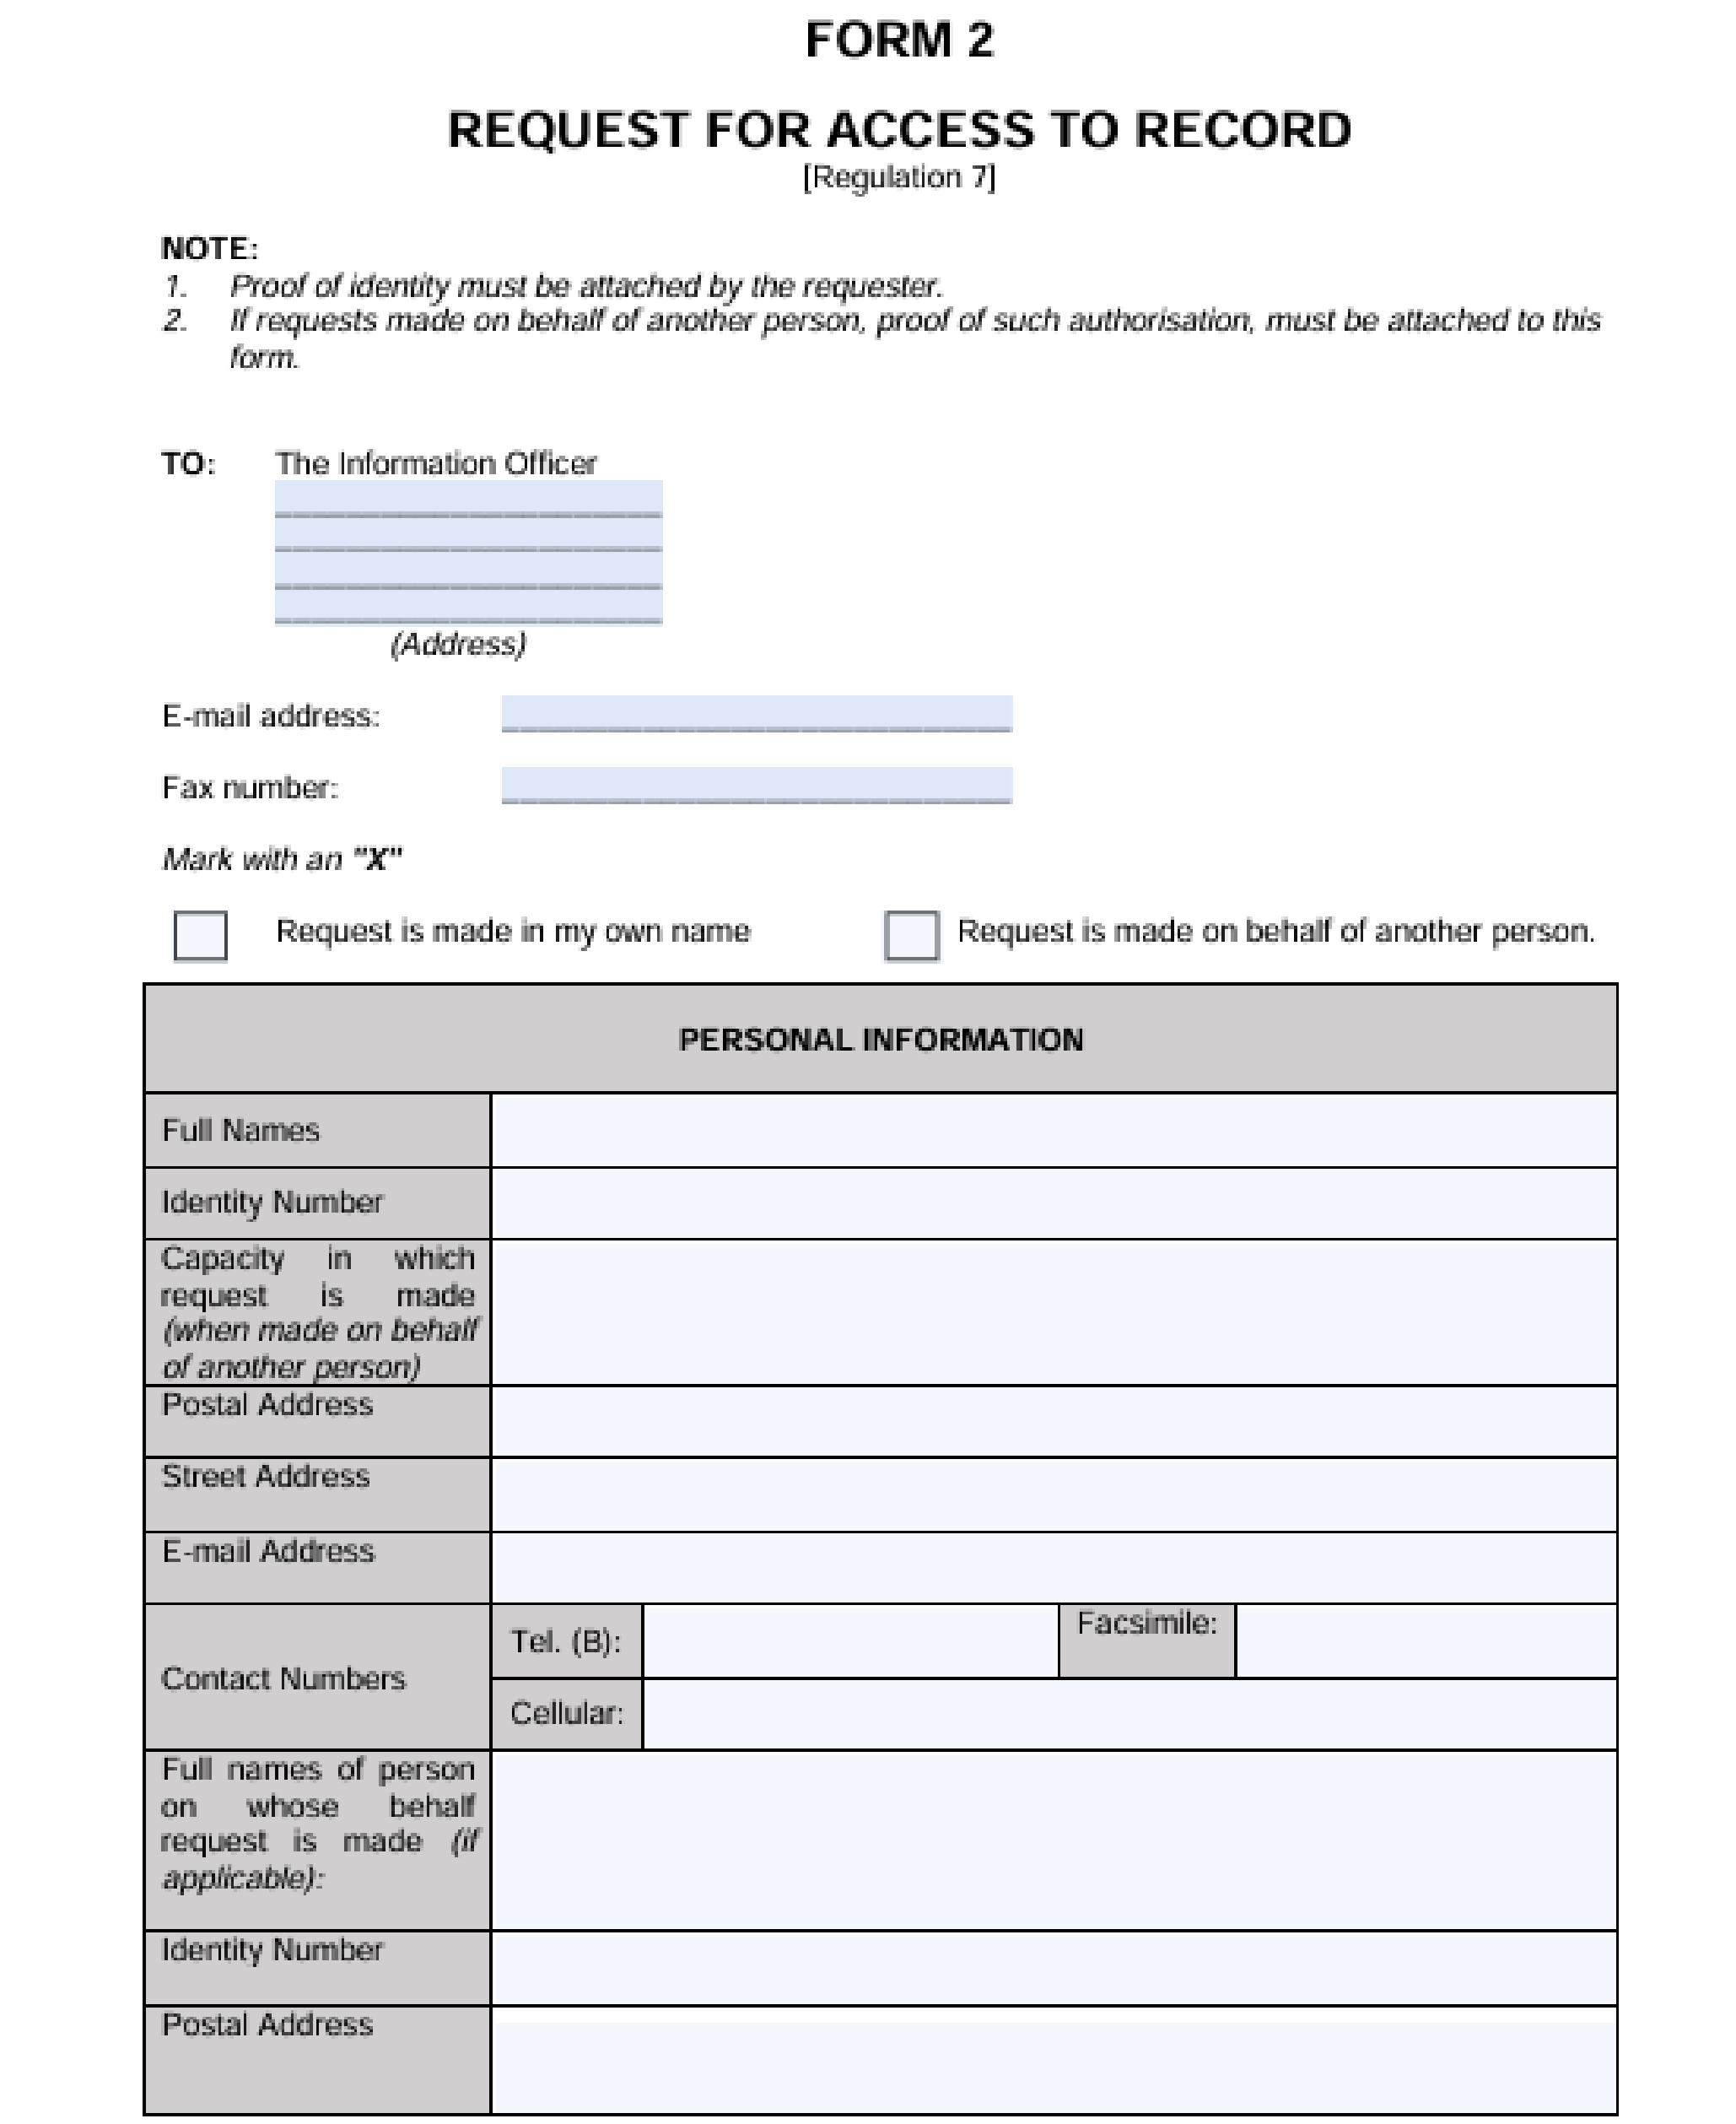

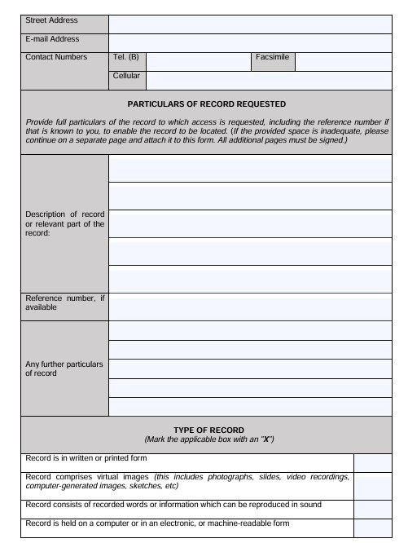

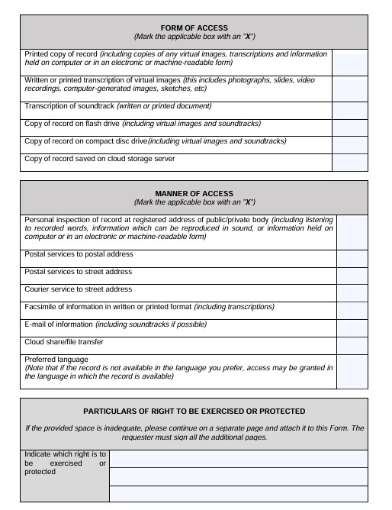

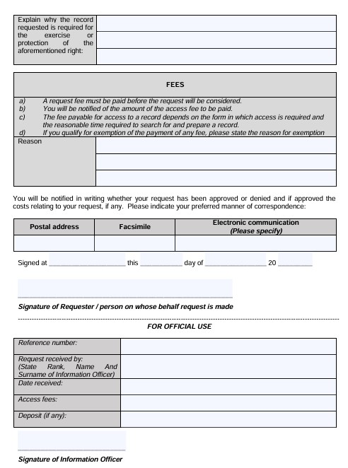


Item | Description | Amount
1 | The request fee payable by every Requester: | R140.00
2 | Photocopy of A4-size page: | R2.00 per page or part thereof
3 | Printed copy of A4-size page: | R2.00 per page or part thereof
4 | For a copy in a computer-readable form on:  - flash drive (to be provided by the Requester):  - compact disc:  - if provided by the Requester:  - if provided to the Requester: | R40.00  R40.00  R60.00
5 | For a transcription of visual images per A4-size page: | Service to be outsourced. Will depend on quotation from Service provider.
6 | Copy of visual images: | Service to be outsourced. Will depend on quotation from Service provider.
7 | Transcription of an audio record, per A4-size page: | R24.00
8 | For a copy of an audio record on:  - flash drive (to be provided by the Requester):  - compact disc:  - if provided by the Requester:  - if provided to the Requester: | R40.00  R40.00  R60.00
9 | To search for and prepare the record for disclosure for each hour or part of an hour, excluding the first hour, reasonably required for such search and preparation: | R145.00
 | To not exceed the total cost of: | R435.00
10 | Deposit: If search exceeds six hours: | One third of amount per request calculated in terms of items 2 to 8.
11 | Postage, email, or any other electronic transfer: | Actual expense, if any.


